深 圳 大 学 实 验 报 告

课程编号： 2801000049

课程名称： 机器学习

实验项目名称： Machine Learning Task 3 clustering

学院： 电子与信息工程学院

专业： 电子信息工程

指导教师： 麦晓春

报告人： 古炜 学号：2022280327 班级： 文华班

实验时间： 2024年5月24日至6月7日

实验报告提交时间： 2024年6月7日

教务部制
1. Experimental Purposes and Requirements
1. Load 5 datasets:
noisy_circles.txt(n_clusters=2)
noisy_moons.txt(n_clusters=2)
blobs.txt(n_clusters=3)
aniso.txt(n_clusters=3)
no_structure.txt(n_clusters=3)
2. Drawing scatterplots to visualize data sets.
3. Use K-means Clustering on all the data sets separately, and visualize the clustering results.
4. Use DBScan on all the data sets separately, adjust the parameter eps for different datasets, and visualize the clustering results.
2. Experiment Contents and Process
2.1 Experiment 1
(1) Experimental Contents/Introduction
- Experiment Introduction:
This experiment explores the application and effectiveness of clustering algorithms on different types of datasets. Specifically, we will use two common clustering algorithms, K-means and DBSCAN, to cluster five different datasets and observe the clustering results.

- Experiment process:
Firstly, we will load five different types of datasets: noisy_circles.txt, noisy_moon.txt, blobs.txt, aniso.txt, and no_structure.txt. Next, we will use scatter plots to visualize these datasets in order to visually understand their distribution. Then, we will cluster each dataset separately using the K-means algorithm and DBSCAN algorithm, and plot the clustering results for comparison and observation.

(2) Methods
- K-means:
The K-Means algorithm is a typical partition based clustering algorithm and an unsupervised learning algorithm. The idea of the K-Means algorithm is very simple. For a given sample set, Euclidean distance is used as an indicator to measure the similarity between data objects. The similarity is inversely proportional to the distance between data objects, and the larger the similarity, the smaller the distance.
The core idea of the K-Means algorithm is to first randomly select k initial cluster centers Ci (i ≤ 1 ≤ k) from the dataset, calculate the Euclidean distance between the remaining data objects and the cluster center Ci, find the cluster center Ci closest to the target data object, and assign the data object to the cluster corresponding to the cluster center Ci. Then calculate the average value of data objects in each cluster as the new cluster center, and proceed to the next iteration until the cluster center no longer changes or reaches the maximum number of iterations.
The algorithm steps for K-means:
①. Firstly, we determine a k value, which means we want to cluster the dataset to obtain k sets.
②. Randomly select k data points from the dataset as centroids.
③. For each point in the dataset, calculate its distance from each centroid (such as Euclidean distance), and divide it into the set to which the centroid belongs, based on which centroid it is closest to.
④. After grouping all the data into a set, there are a total of k sets. Then recalculate the centroid of each set.
⑤. If the distance between the newly calculated centroid and the original centroid is less than a set threshold (indicating that the position of the recalculated centroid does not change much, tends to stabilize, or converges), we can consider that the clustering has achieved the desired result and the algorithm terminates.
⑥. If the distance between the new centroid and the original centroid changes significantly, it is necessary to iterate ③-⑤ steps.

The advantages of K-means include simple algorithm, easy implementation, and high computational efficiency. However, K-means also has some drawbacks, such as being sensitive to the selection of initial cluster centers, potentially falling into local optima, and requiring a predetermined number of clusters k.

- DBSCAN:
DBSCAN (Density Based Spatial Clustering of Applications with Noise) is a density based clustering algorithm that divides a dataset into regions with the same density and can discover clusters of any shape. The core idea of this algorithm is to determine clusters by searching for high-density areas in the dataset, and expand clusters by connecting density reachable points.
The main parameters of DBSCAN include: ① eps: defines the maximum distance between two points that are considered neighbors. ② min_samples: defines the minimum number of neighbors required within the neighborhood of a point.
The algorithm steps of DBSCAN: ①. The algorithm runs by arbitrarily selecting a point in the dataset (until all points are accessed). ②. If there is at least a "min_samples" point within the "ε" radius range of that point, then it is considered that all these points belong to the same cluster. ③. Expand clustering by recursively repeating steps 1 and 2 to calculate the neighborhood of each adjacent point.
The advantages of DBSCAN include the ability to handle clusters of any shape, no need to specify the number of clusters in advance, and robustness to noisy points. However, DBSCAN also has some drawbacks, such as being sensitive to parameter selection and may not be flexible enough for areas with significant density changes in the dataset.

(3) Experimental Results and Analysis
- Visualization results of five datasets:
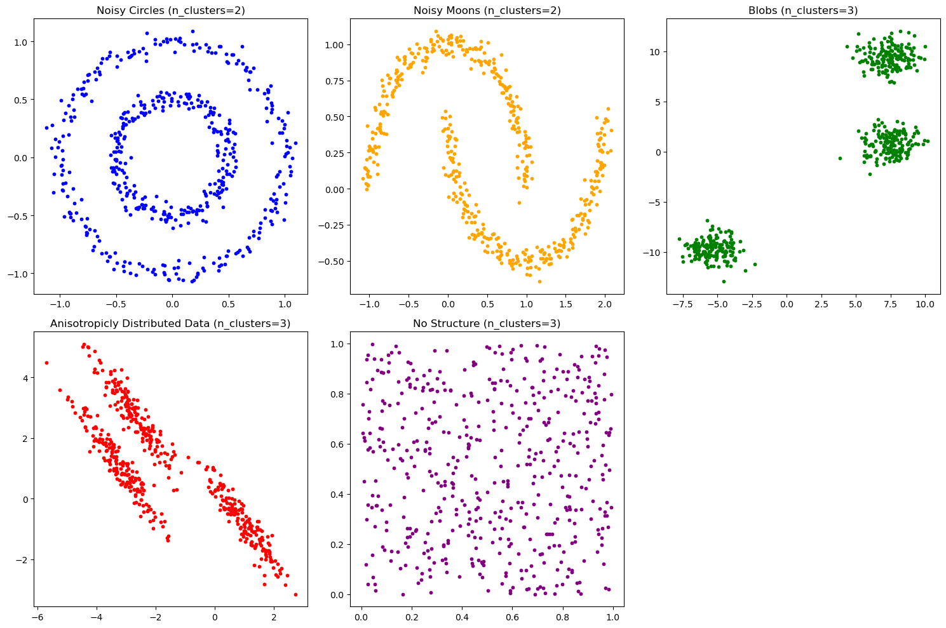
The noisy_circles dataset contains two circular clusters, one ring surrounding the other, and the data points have some noise, so they are not entirely ideal circles. The noisy_moons dataset contains two semi lunar clusters that surround each other, and the data points also have some noise, making the shape not completely smooth. The blobs dataset contains three distinct, Gaussian distributed spherical clusters with significant intervals between them. The clusters in the aniso dataset are anisotropic and have an elliptical shape with obvious directionality The no_structure dataset does not have a clear cluster structure, and data points are randomly distributed.

- Clustering results:
- For noisy_circles dataset:
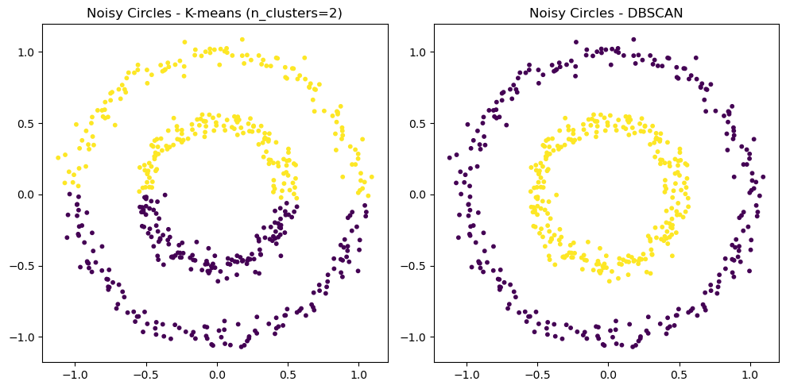
In the K-means clustering results, as it allocates points by minimizing the square distance within the cluster, it cannot handle complex structures such as concentric circles. The result is to divide two concentric circles into upper and lower parts. For this dataset, K-means cannot capture the true structure of the data very well. In the DBSCAN clustering results, as DBSCAN defines clusters based on density, it can better identify two concentric circular clusters for this dataset. DBSCAN can also identify noise points (points marked as -1). These noise points do not belong to any cluster because the number of points in their neighborhood is insufficient for min_samples. DBSCAN performs better in this dataset, accurately identifying two circular clusters.

- For noisy_moons dataset:
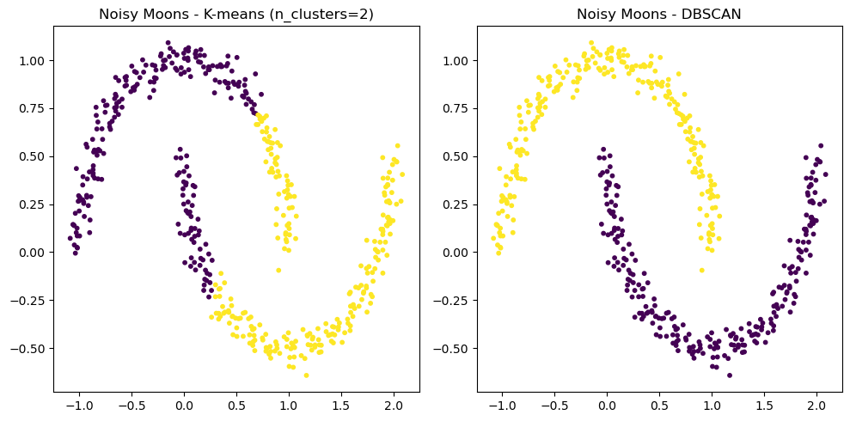
In the K-means clustering results, the result is to divide two half moons into two parts: left and right. For this dataset, K-means cannot capture the true structure of the data very well. In the DBSCAN clustering results, it can better identify two crescent shaped clusters, which are more in line with the true structure of the dataset.

- For blobs dataset:
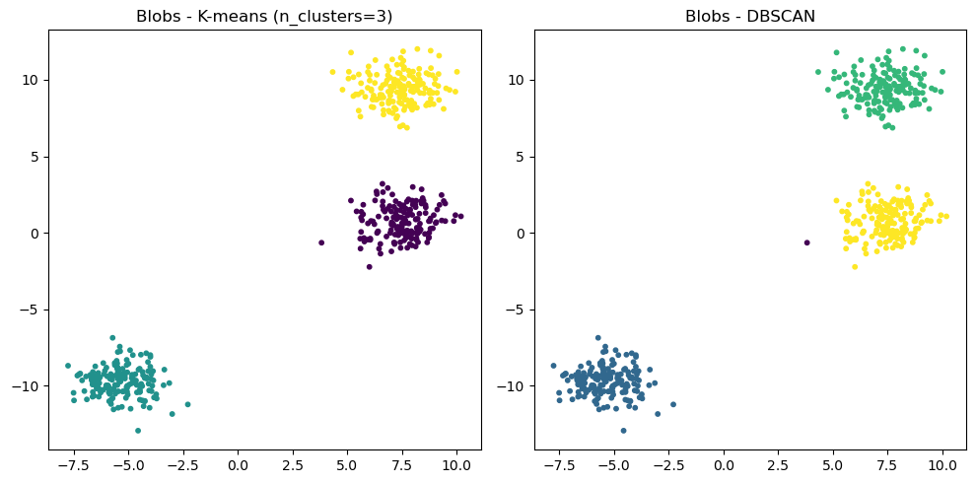
On the Blobs dataset, both K-means and DBSCAN can effectively identify the structure of clusters. K-means has a particularly significant effect on the structure of this spherical cluster, while DBSCAN can effectively identify clusters and process noise points through its density clustering characteristics. Overall, for datasets with clear cluster distribution, both K-means and DBSCAN perform well.

- For aniso dataset:
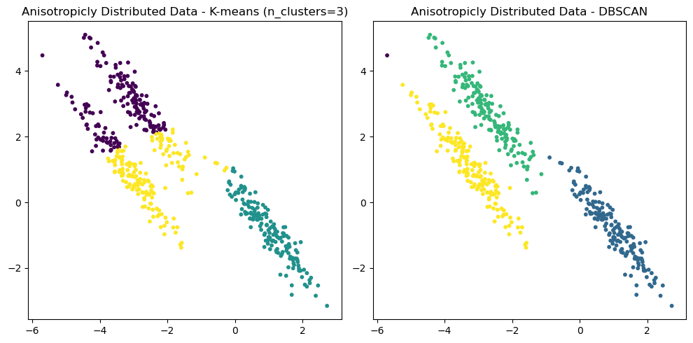
The Aniso dataset has the characteristic of anisotropy, that is, the distribution of data is not spherical, but elliptical. For this dataset, DBSCAN performs significantly better than K-means. K-means divides the data into three parts: left, middle, and right, while DBSCAN divides three elliptical parts into three clusters. The density clustering method of DBSCAN enables it to better identify clusters with complex shapes, while the spherical assumption of K-means limits its processing ability. Therefore, when dealing with anisotropic datasets, DBSCAN is a better choice.

- For no_structure dataset:
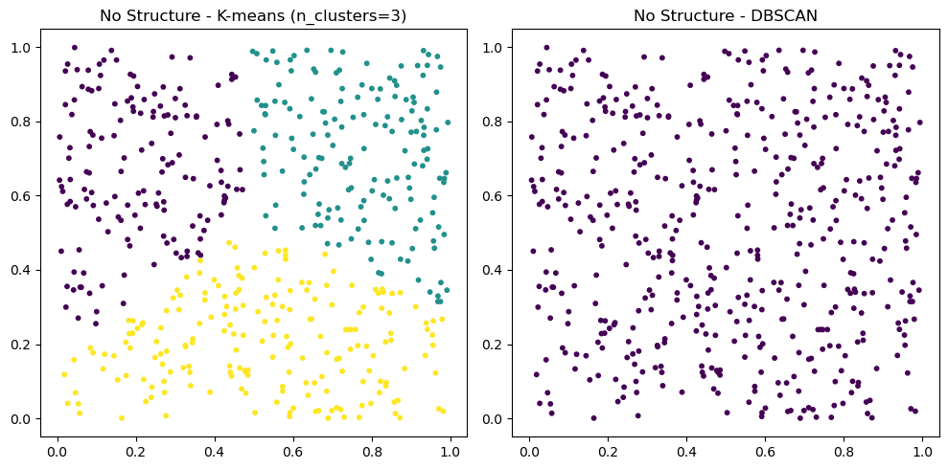
For the no_structure dataset, DBSCAN performs better than K-means. K-means will force cluster allocation in data without obvious cluster structure, while DBSCAN can correctly recognize the uniform distribution characteristics of the data and will not artificially create clusters. DBSCAN does not force cluster allocation in data without a cluster structure, only identifying noise points, which reflects the actual situation of the dataset. Therefore, when dealing with data without obvious cluster structures, DBSCAN is a more suitable choice.

3. Discussion and Conclusions
In this experiment, we applied and analyzed two clustering algorithms, K-means and DBSCAN, on five different datasets. The structural characteristics of each dataset are different, which demonstrates the advantages and disadvantages of the two clustering algorithms in different situations.
For K-means clustering, its calculation speed is fast, the algorithm is simple, and it is easy to understand and implement. Good performance for spherical clusters and excellent performance for clusters with clear and uniform distribution. But the number of clusters (k) needs to be specified in advance. Moreover, it is sensitive to the shape of clusters and can only handle spherical clusters, not complex shaped clusters.
For DBSCAN clustering, it does not require specifying the number of clusters and can automatically determine the number of clusters. And it can recognize clusters of any shape, showing superior performance on complex shaped datasets. And it can handle noise and outliers, and identify points with insufficient density as noise points. However, it is sensitive to the parameters eps and min_samples, and improper parameter selection can affect the clustering results. The computational complexity is also high, and the computational efficiency is low for large-scale datasets.
Overall, through this experiment, we can see that K-means and DBSCAN each have their own advantages and disadvantages, and are suitable for different types of datasets. When processing data with obvious spherical cluster structures, K-means performs superior; When dealing with complex shaped clusters or noisy data, DBSCAN performs better. Therefore, selecting a suitable clustering algorithm requires comprehensive consideration based on the characteristics of the data and actual needs.
指导教师批阅意见：

成绩评定：

指导教师签字：
年 月 日
备注：
注：1、报告内的项目或内容设置，可根据实际情况加以调整和补充。
2、教师批改学生实验报告时间应在学生提交实验报告时间后10日内。

